UNIVERSITY OF BUEA
Faculty of Engineering and Technology
Department of Electrical and Electronic Engineering
CEF488 Systems and Network Programming
Lab 1
Process Management, Signals & Advanced IPC

Group3 Members

Member Name | Signature | Date
Emengu Njualem Fondong | FE25A062 | 25/04/2026
Moukam Hako | FE23A096 | 25/04/2026
Nyonyoh divine-Fortune Banfila | FE23A128 | 25/04/2026
Tabot Ghislain Orock | FE23A146 | 25/04/2026

Course instructor:
Mr. FORCHA GLEN

ACADEMIC YEAR 2025/2026

Honesty Report

Task | Responsible Member(s)
Task 1 Daemonization & Pipes | Emengu Njualem Fondong
Task 2 Signal Handling | Tabot Ghislain Orock
Task 3 Robustness and The combination of all the code | Nyonyoh divine-Fortune Banfila
Prelab Questions and The combination of all the code | Moukam Hako

Signatures confirming the accuracy of this table:
Member Name | Signature
Emengu Njualem Fondong | FE25A062
Moukam Hako | FE23A096
Nyonyoh divine-Fortune Banfila | FE23A128
Tabot Ghislain Orock | FE23A146

Contents
Abstract 3
Prelab Answers 5
Methodology 7
Results 10
Analysis and Discussion 16
Conclusions 18
References 19

Abstract
This report presents the design, implementation, and testing of a Linux daemon developed for Lab 1 of CEF488 Systems and Network Programming. The objective was to build practical experience with core UNIX system programming concepts including process creation, deamonization, inter-process communication using unnamed pipes, non-blocking I/O, and signal handling.
The implementation was split across three tasks. Task 1 covered the complete six-step deaminization procedure and established bidirectional pipe communication between a parent process and a child accumulator. Task 2 extended this with proper signal handling using sigaction() for SIGTERM, SIGINT, and SIGCHLD, allowing the daemon to shut down gracefully at any point. Task 3 added robustness features including PID file locking with flock(), resource limit simulation using setrlimit(), child-response timeout detection, and clean error recovery from pipe failures.
All tasks were verified through both a debug build that runs in the terminal and a release build that daemonizes correctly. Results confirmed correct IPC behaviour, zombie-free process management, and reliable single-instance enforcement.

Objectives
The main learning objectives of this lab were:
- Understand and implement the standard six-step UNIX daemon creation procedure.
- Create and manage child processes using fork() and handle their lifecycle correctly.
- Implement bidirectional inter-process communication using two unnamed pipes.
- Apply non-blocking I/O with fcntl() and handle EAGAIN return values gracefully.
- Install signal handlers using sigaction() for SIGTERM, SIGINT, and SIGCHLD.
- Prevent zombie processes by reaping children with waitpid() and WNOHANG inside SIGCHLD handlers.
- Use setrlimit() to simulate process resource exhaustion and handle fork() failures.
- Enforce single-instance daemon operation using flock() on a PID file.
- Integrate syslog() for structured daemon logging throughout the process lifecycle.

Prelab Answers
1. Process Group vs Session
A process group is a collection of related processes that can receive signals together, identified by a PGID. A session is a higher-level grouping of one or more process groups, typically tied to a single controlling terminal.
A daemon must call setsid() to create a new session. This detaches it from any controlling terminal it inherited from its parent. Without this step, signals sent to the terminal such as SIGHUP when the terminal closes would reach the daemon and potentially kill it.
2. Three Steps of Daemonization
- fork() and exit the parent: The parent exits immediately, returning control to the shell. The child continues in the background. It also ensures the child is not a process group leader, which is a prerequisite for setsid().
- setsid(): Creates a new session with the child as session leader, fully detached from any controlling terminal.
- Close all open file descriptors: The child inherits all fds from the parent. Closing them prevents resource leaks and avoids accidental I/O on inherited channels.

3. sigaction() vs signal()
signal() is the older interface with non-portable semantics: on some systems the handler resets to default after firing, on others it does not. sigaction() is the POSIX standard. It provides a struct sigaction that gives full control over signal masking, flags like SA_RESTART, and consistent behaviour across all POSIX systems.
4. Purpose of SA_RESTART
When a signal interrupts a blocking system call, the default behaviour is to return -1 with errno set to EINTR. SA_RESTART instructs the kernel to automatically restart the interrupted system call, simplifying application code so the signal handling logic stays confined to the handler.
5. Why printf() is Unsafe in Signal Handlers
printf() uses internal buffers and locks on the FILE structure. If a signal arrives while the main program is inside printf(), a handler that also calls printf() tries to acquire the same lock, causing a deadlock or buffer corruption. The safe alternative is write(), which is explicitly async-signal-safe. Example: write(STDERR_FILENO, "signal caught\n", 14);
6. Bidirectional Communication with Two Unnamed Pipes
A single pipe is unidirectional. Two pipes are needed: pipe_p2c carries integers from parent to child (parent writes, child reads); pipe_c2p carries sums from child to parent (child writes, parent reads). Each process must close the ends it does not use. Leaving unused ends open prevents the reader from ever seeing EOF.
7. PIPE_BUF and Write Atomicity
PIPE_BUF is the minimum size (at least 512 bytes on POSIX, 4096 on Linux) guaranteed to be written atomically to a pipe. Writes up to this size either complete entirely or block they are never interleaved with another writer. Writes larger than PIPE_BUF may be split and interleaved. In this lab only sizeof(int) bytes are written at a time, well below PIPE_BUF, so atomicity is guaranteed.
8. Effect of fcntl(fd, F_SETFL, O_NONBLOCK)
Without O_NONBLOCK, read() blocks until data arrives and write() blocks if the pipe buffer is full. After setting O_NONBLOCK, both calls return immediately: read() returns -1 with errno EAGAIN if no data is available, and write() returns -1 with EAGAIN if the buffer is full. This lets a process attempt I/O and continue doing other work instead of stalling.
9. Limiting Processes with setrlimit()
setrlimit() with RLIMIT_NPROC sets the maximum number of processes the user can create. It takes a struct rlimit containing rlim_cur (enforced soft limit) and rlim_max (hard ceiling). Setting rlim_cur at or below the current process count causes the next fork() to fail with errno EAGAIN.

Methodology
Design Decisions
The implementation was divided into three self-contained source files, one per task, each building on the previous. This structure allows each task to be compiled and demonstrated independently, making it easier to isolate behaviour during testing and grading.
Unnamed pipes were chosen for IPC because they are the simplest mechanism for communication between a parent and child sharing a common ancestor. Non-blocking I/O was applied to the parent's pipe ends so the main loop could continue sending integers without stalling on reads. sigaction() was used in preference to signal() for all handlers because its behaviour is portable and predictable.
Code Structure
Source File | Purpose
lab1_common.h | Shared constants: PID file path, syslog identifiers, iteration count, timeout value, debug macro.
task1_daemon.c | Task 1: six-step daemonization, PID file, bidirectional pipes, child accumulator, non-blocking I/O, syslog.
task2_signals.c | Task 2: extends Task 1 with sigaction() handlers for SIGTERM, SIGINT, SIGCHLD and while(g_running) main loop.
task3_robust.c | Task 3: extends Task 2 with flock() locking, setrlimit() simulation, pipe failure guards, child timeout.
Makefile | Builds all three tasks in both release and debug modes with consistent -Wall -Wextra -Werror flags.

Key Functions
Function | File | Description
daemonize() | All tasks | Performs all six daemonization steps.
write_pid_file() | task1 / task2 | Creates /tmp/mydaemon.pid and writes the daemon PID.
write_pid_file_locked() | task3_robust.c | Same as above but acquires an exclusive flock() lock.
set_nonblock() | All tasks | Applies O_NONBLOCK to a file descriptor via fcntl().
child_process() | All tasks | Child loop: reads integers, accumulates sum, writes reply.
handle_term() | task2 / task3 | SIGTERM/SIGINT handler: sets g_running = 0.
handle_chld() | task2 / task3 | SIGCHLD handler: calls waitpid(-1, WNOHANG) in a loop.
install_handler() | task2 / task3 | Wrapper around sigaction() for clean handler installation.
cleanup() | task3_robust.c | Releases flock, closes PID fd, calls unlink(PID_FILE).
nanosleep_ms() | All tasks | Sleeps for N milliseconds using nanosleep().

Libraries and Tools
- unistd.h, fcntl.h, signal.h, sys/wait.h core POSIX process and IPC interfaces.
- syslog.h structured logging to the system log daemon.
- sys/resource.h setrlimit() for RLIMIT_NPROC resource limits.
- sys/file.h flock() for advisory file locking.
- GCC with -Wall -Wextra -Werror strict compilation; all warnings treated as errors.

Results
Task 1 Daemon Execution and Pipe Communication
The debug build was run first to verify correct behaviour. The parent sent integers 1 through 10, the child accumulated the running sum, and the parent read each sum via the non-blocking pipe.

The release daemon was then started. The PID file was created and the process appeared as a session leader with no controlling terminal.
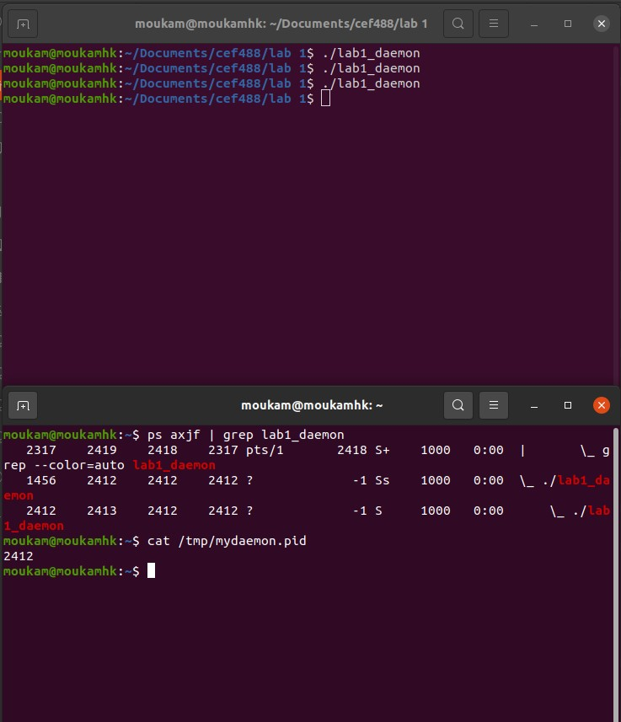
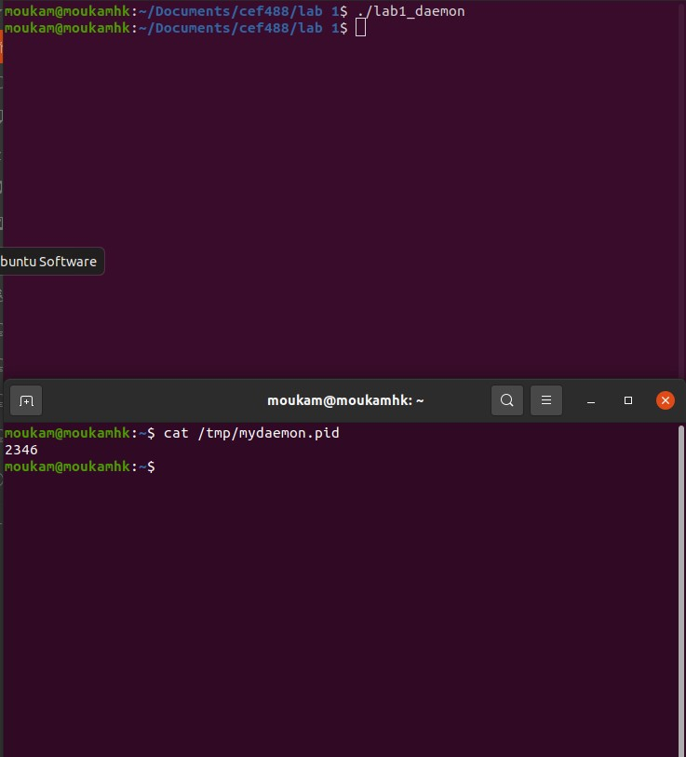
Task 2 Signal Handling
The daemon was started and interrupted mid-run using kill -TERM. Syslog confirmed detection of SIGTERM, child termination, PID file removal, and clean exit.
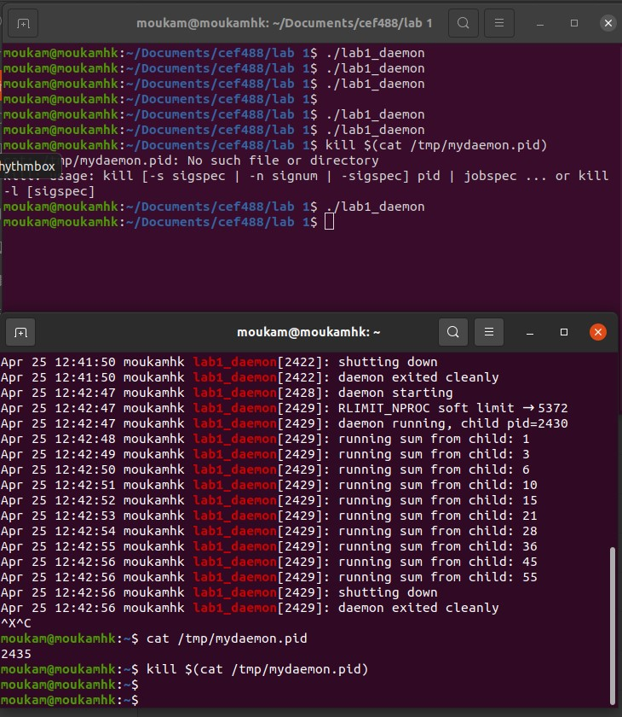
Task 3 Robustness
Four robustness scenarios were tested:
- setrlimit() test: syslog immediately after launch shows 'second fork() failed as expected' while the daemon continues normally.
- flock() test: a second instance attempt printed the instance-already-running error and exited immediately.
- Pipe failure guard: verified by code inspection; the guard removes the PID file and exits cleanly on pipe() failure.
- Child timeout: verified by reducing CHILD_TIMEOUT to 2 seconds in debug mode, triggering the timeout log and clean shutdown.

Source Files Summary
File | Role
lab1_common.h | Shared definitions and debug macro
task1_daemon.c | Task 1 implementation
task2_signals.c | Task 2 implementation
task3_robust.c | Task 3 implementation
Makefile | Build system

Analysis and Discussion
Did the Implementation Meet the Requirements?
Yes. All three tasks were implemented and verified against the lab specification. The final sum of 55 (the sum of integers 1 through 10) was consistently produced across all test runs, confirming the correctness of the child accumulator logic. The daemon correctly follows all six daemonization steps, handles all three required signals, and implements all four robustness features.
Challenges Faced
The main challenge was with the ordering of openlog() relative to daemonize(). In the initial implementation, openlog() was called before daemonize(). The daemonization step that closes all file descriptors also closed the socket openlog() had opened to /dev/log, leaving the syslog subsystem in a broken state. The daemon would fail silently after daemonization without ever writing the PID file. The fix was to call openlog() after daemonize() completes so it opens a fresh connection in the new session.
A second challenge arose with the setrlimit() value. The initial hardcoded limit of 5 was far below the number of processes already running under the user's UID on a typical Ubuntu system. This caused the limit to be breached before the first fork() ran, killing the real worker child. The fix was to use the kernel's own rlim_cur value and set the new limit to rlim_cur + 1, providing exactly one slot for the real child before the demo fork() fails.
Non-blocking I/O Observations
Non-blocking reads on the parent side produced frequent EAGAIN returns early in each run, when the child had not yet replied. This is the expected behaviour. By the middle of the run, replies were arriving consistently within the one-second sleep window. The EAGAIN handling confirmed that the parent never blocks, which is the core requirement of the non-blocking pipe design.
Improvements for a Production Version
- Replace the integer pipe protocol with length-prefixed message framing to support variable-length messages.
- Use signalfd() combined with epoll() to integrate signal handling into a single event loop, eliminating volatile flag polling.
- Add log rotation rather than relying solely on syslog, which can fill the system log on long-running deployments.
- Implement an automatic child restart mechanism instead of terminating the daemon when the child dies.
- Use a PID file in /var/run/ rather than /tmp/ to follow FHS conventions for system daemons.

Conclusions
This lab gave us hands-on experience with several foundational UNIX system programming concepts that underpin real-world services like sshd, httpd, and network monitoring agents.
The most important lesson was the significance of ordering in the daemonization procedure. Each step exists for a specific reason, and small deviations such as calling openlog() before closing file descriptors can produce subtle, hard-to-diagnose failures. Developing with a debug build that skips daemonization was essential for isolating logic bugs before introducing the complexity of a background process.
Signal handling reinforced the importance of keeping handlers minimal and async-signal-safe. The pattern of setting a flag in the handler and acting on it in the main loop is simple but robust, and is the standard approach used in production daemons.
The robustness task showed that resource limits are a real operational concern. A well-written daemon must handle fork() failures gracefully rather than crashing, and the flock() locking pattern for PID files is a practical technique used widely in production Linux software.

References
1. Kerrisk, M. (2010). The Linux Programming Interface. No Starch Press.
2. Stevens, W. R., & Rago, S. A. (2013). Advanced Programming in the UNIX Environment (3rd ed.). Addison-Wesley.

